1. Introduction 2
2. Objectives 2
2. 1. Core Objectives: 2
2.2. System-Level Objectives: 2
3. Methodology 3
4. Phase Details 3
4.1. Influencer List Scraping 3
4.2. Browser-Based Instagram Data Extraction 3
4.2.1 Login Automation: 3
4.2.2 Extracting Profile Name: 4
4.2.3 Extracting Bio, Links, Threads: 4
4.2.4 Extracting Stats: 4
4.2.5 Extracting Comments: 4
4.2.6 Extracting Profile Image: 4
4.3. Instagram API Data Extraction 4
5. Limitations 5
6. Future Improvements 5
7. Conclusion 5

1. Introduction
Instagram has become one of the world’s most influential digital platforms, especially for influencer marketing, content creation, brand partnerships, and audience engagement. With millions of active creators, extracting structured data from Instagram is critical for analytics, market research, and digital marketing pipelines.
However, Instagram does not provide accessible public APIs for general user profile analysis, and the website uses dynamic, JavaScript-driven content, making automated data extraction challenging.
This project solves that problem by developing a multi-phase automated Instagram scraping system capable of reliably collecting:
• Influencer identities
• Profile attributes
• Bio descriptions
• External links
• Threads username
• Followers, following, posts count
• Comments from recent posts
• Profile image URLs
• Official metadata via Instagram’s internal web API

2. Objectives

2. 1. Core Objectives:
1. Scrape authoritative influencer lists from public websites.
2. Automate Instagram login with persistent session cookies.
3. Extract complete profile metadata for each influencer.
4. Store all extracted information in structured Excel files.
5. Build a secondary data-collection pipeline using Instagram’s hidden internal API.

2.2. System-Level Objectives:
• Ensure scraping robustness using multiple fallback extraction methods.
• Prevent bot-detection by implementing human-like delays.
• Save progress incrementally to avoid data loss.
• Create a modular, expandable, and maintainable scraping architecture.
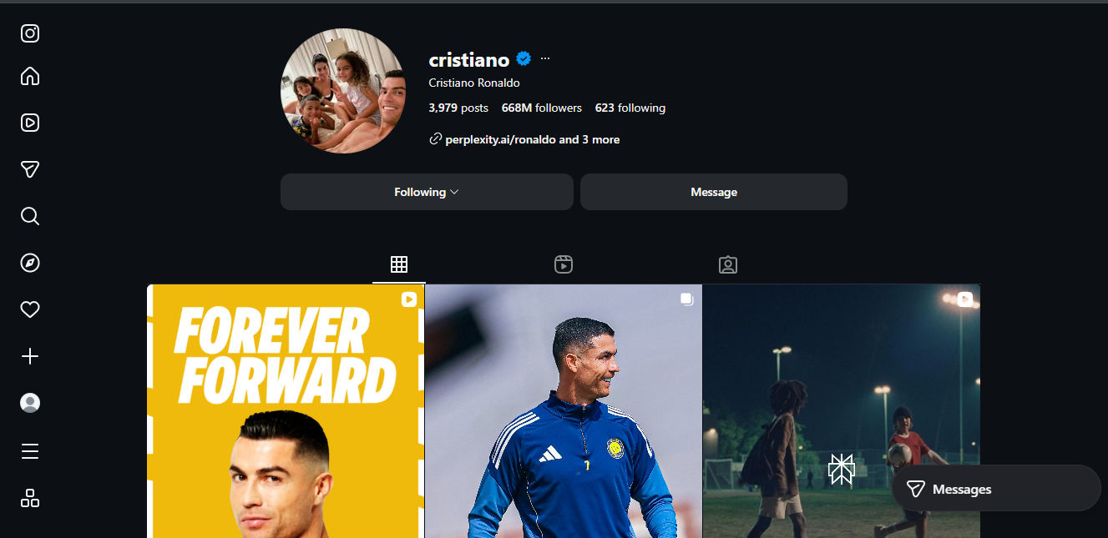

3. Methodology
The project follows a three-phase hybrid scraping approach:
• Step 1: Influencer Collection
• Step 2: Instagram Browser Automation
• Step 3: API-Based Data Extraction
Tools Used:
Python, Selenium WebDriver, ChromeDriver, Requests, Pandas, Pickle, WebDriverWait, XPath & CSS selectors, Excel Writer.

4. Phase Details

4.1. Influencer List Scraping
Objective: Collect 120 influencer usernames and names from external website TopNine.co.
Process:
• Load site using Selenium
• Remove obstructive elements
• Iterate through 10 tabs of influencers
• Extract full name and handle
Output: influencers.xlsx

4.2. Browser-Based Instagram Data Extraction
Includes login automation, profile navigation, and detailed multi-layer data extraction.

4.2.1 Login Automation:
• Load cookies
• If unavailable, manual login + cookie saving
• Enables seamless long scraping sessions

4.2.2 Extracting Profile Name:
• Load profile URL
• Extract name using flexible XPath
• Save to profile_data.xlsx

4.2.3 Extracting Bio, Links, Threads:
• Multi-layer fallback XPath
• Extract bio text, external website, threads username
• Store in combined format

4.2.4 Extracting Stats:
• Extract posts, followers, following
• Convert numbers to K/M/B format

4.2.5 Extracting Comments:
• Open first post
• Extract first 5 comments using multiple XPath strategies

4.2.6 Extracting Profile Image:
• Extract high-resolution profile picture via <img> src
• Alternate class-based fallback

4.3. Instagram API Data Extraction
The final phase of the project leverages Instagram’s hidden internal endpoint /web_profile_info/ to retrieve structured JSON metadata for any public username. This method bypasses the limitations of browser scraping by directly querying Instagram’s web API, which provides cleaner and more reliable data. Access to this endpoint requires valid session cookies and authenticated request headers, both obtained during the Selenium login phase. Once authenticated, the API returns a complete set of user information, including follower count, following count, total posts, verification status, privacy status, biography, external URLs, and high-definition profile picture links. The project processes these JSON responses, extracts all relevant fields with fallback safety checks, and saves the results incrementally into an Excel file named instagram_data.xlsx, ensuring data integrity even during long scraping sessions.

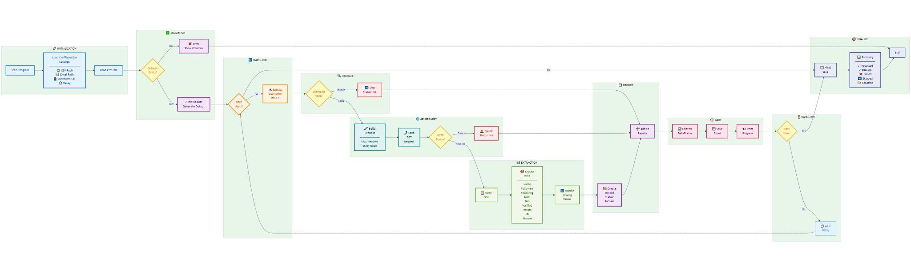

5. Limitations
Despite the robustness of the system, several limitations remain. Instagram frequently updates its DOM structure, meaning that XPath or CSS selectors used for scraping may break and require periodic updates. Additionally, Selenium-based scraping is inherently slow, as it must fully render each page and mimic user interaction, which limits scalability for large datasets. The internal Instagram API used in Phase 3 can also trigger rate limits, especially when multiple requests are sent in a short time or when authentication cookies are reused excessively. Data accessibility is further restricted by private accounts, which prevent retrieval of follower statistics, posts, bios, and images. Finally, some users may simply lack posts, bios, external links, or profile details, resulting in incomplete data even when the scraping pipeline functions correctly.

6. Future Improvements
To enhance the efficiency and reliability of the scraping pipeline, several improvements can be implemented. Integrating undetected-chromedriver would provide enhanced stealth capabilities, reducing the likelihood of Instagram detecting and blocking automated browser sessions. Adding rotating proxies would help distribute request traffic across multiple IP addresses, minimizing rate-limit risks and enabling large-scale scraping. Migrating the system to an asynchronous framework such as Playwright would significantly increase speed by allowing multiple profiles to be processed in parallel. Storing extracted data in SQL or NoSQL databases would improve long-term data management, enable scalable querying, and support integration with analytics tools. A change-detection mechanism could be added to ensure that only accounts with updated information are re-scraped, reducing unnecessary processing. Finally, developing a comprehensive comment extraction module capable of scraping multiple posts and deeper comment threads would expand the usability of the dataset and provide richer insights for analysis.

7. Conclusion
This Instagram Web Scraping system provides an efficient hybrid solution using both browser automation and API-based extraction to gather reliable and detailed profile data. It supports accurate influencer discovery, consistent scraping of bios, links, comments, and profile statistics, and maintains stable sessions through cookie-based login. With its multi-phase architecture and fallback mechanisms, the system remains flexible against DOM changes and minimizes data loss. Overall, it delivers a practical and scalable tool for marketers, analysts, and data professionals who need structured Instagram datasets for research, analytics, and decision-making.

